Heart Disease Prediction using Machine Learning: A Comparative Study of K-Nearest Neighbors, Decision Tree, and Random Forest Algorithms

ABSTRACT
Heart disease is still one of the top causes of death around the world, making early and precise prediction systems needed. Providing data-driven insights for diagnosis is where very powerful machine learning techniques come into play to assist medical professionals. Here we present a comparison between three widely used machine learning algorithms the K-Nearest Neighbors (KNN), Decision Tree, and Random Forest to predict heart diseases. The dataset is obtained from Kaggle, which consists of a total of 1888 instances and 14 attributes, both for training and evaluating the model. This data is processed with standard scaling and ik split into training & test sets. The evaluation metrics used to measure these models include accuracy, precision and recall, confusion matrix. From experiments, Random Forest achieves the best performance while KNN and Decision Tree follow. The study demonstrates the effectiveness of ensemble methods for increasing predictive accuracy and reducing over-fitting.

KEYWORDS
Heart Disease, Machine Learning, KNN, Decision Tree, Random Forest, Classification, Healthcare Analytics.
INTRODUCTION
Heart illness is a high global fitness problem that ranks excessive amongst the motives of my demise. This happens due to the narrowing or blockage of coronary arteries from plaque build-up reducing blood flow to the heart. For reducing mortality rates, early detection and diagnosis plays a vital role.
As highlighted in previous studies, traditional diagnostic methods rely heavily on clinical expertise and manual interpretation, which may lead to errors and inconsistencies. With the rapid growth of healthcare data, machine learning techniques have emerged as powerful tools for analyzing complex datasets and assisting in medical decision-making.
Machine learning models can process large volumes of patient data and identify hidden patterns that may not be easily detectable by human experts. This capability enables the development of automated systems for disease prediction, thereby improving diagnostic accuracy and efficiency.
In the past, researchers mostly looked at one algorithm at a time, like KNN, but now it's time to compare several models to see which one works best. So, this study wants to test and compare how well KNN, Decision Tree, and Random Forest algorithms do on a dataset about heart disease that combines information from different sources. This will help us figure out which approach is the most effective. By looking at multiple models, we can get a better understanding of their strengths and weaknesses, and make a more informed decision about which one to use. The goal is to find the best way to analyse the heart disease data, and to see if one algorithm stands out from the others.

RELATED WORK
Several machine learning techniques have been applied to heart disease prediction. The study in proposed a KNN-based model and achieved an accuracy of approximately 91.99%, demonstrating the effectiveness of distance-based classification.
Other studies have looked at different algorithms like Naïve Bayes, Support Vector Machines, and Logistic Regression. When you compare them, it seems that methods that combine multiple models, like Random Forest, usually work better than individual models. This is because they can reduce the differences in results and stop the models from becoming too specialized, which is known as overfitting.
But there's a problem with a lot of the research that's been done so far - it's been limited by small datasets or a lack of thorough comparisons. This study builds on what's come before by using a bigger, combined dataset and testing out multiple algorithms in the same conditions, to see how they really stack up.

DATASET DESCRIPTION
The dataset used in this study is a merged heart disease dataset obtained from the Kaggle repository. It consists of:
- Total instances: 1888
- Number of features: 13 input attributes and 1 target variable
- Target variable:
  - 1 → Presence of heart disease
  - 0 → Absence of heart disease
3.1 Feature Description
1. age: Age of the patient (Numeric).

2. sex: Gender of the patient. Values: 1 = male, 0 female.

3. cp: Chest pain type. Values: 0 = Typical angina, 1 Atypical angina, 2 = non-anginal pain, 3 Asymptomatic.

4. trestbps: Resting Blood Pressure (in mm Hg) (Numeric).

5. chol: Serum Cholesterol level (in mg/dl) (Numeric).

6. fbs: Fasting blood sugar > 120 mg/dl. Values: 1 = true, 0 = false.

7. restecg: Resting electrocardiographic results. Values: 0 = Normal, 1 = ST-T wave abnormality, 2 = Left ventricular hypertrophy.

8. thalach: Maximum heart rate achieved (Numeric).

9. exang: Exercise-induced angina. Values: 1 = yes, 0 = no.

10. oldpeak: ST depression induced by exercise relative to rest (Numeric).

11. slope: Slope of the peak exercise ST segment. Values: 0 = Upsloping, 1 = Flat, 2 = Downsloping.

12. ca: Number of major vessels (0-3) colored by fluoroscopy. Values: 0, 1, 2, 3.

13. thal: Thalassemia types. Values: 1 = Normal, 2 Fixed defect, 3 = Reversible defect.

14. target: Outcome variable (heart attack risk). Values: 1 = more chance of heart attack, 0 = less chance of heart attack.

METHODOLOGY
A. Dataset and Feature Engineering
The study utilizes a consolidated dataset containing 1,888 instances. The feature set includes 13 clinical predictors:
- Demographics: Age, Sex.
- Symptomatic Data: Chest pain type (cp), exercise-induced angina (exang).
- Clinical Measurements: Resting blood pressure (trestbps), serum cholesterol (chol), fasting blood sugar (fbs), and maximum heart rate achieved (thalachh).
- Electrocardiographic Results: Resting ECG (restecg), ST depression (oldpeak), and the slope of the peak exercise ST segment (slope).
B. Data Preprocessing
- Normalization: Since KNN utilizes Euclidean distance, features were scaled using the Standard Score:
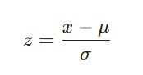
where mu is the mean and sigma is the standard deviation. This prevents high-magnitude features (e.g., chol) from overwhelming binary or small-scale features.
- Splitting: A stratified 80/20 train-test split was used to maintain the ratio of high-risk to low-risk cases in both sets.
C. Algorithmic Framework
- K-Nearest Neighbors (KNN): An instance-based learner that classifies $x$ based on the majority label of its $k$ closest neighbors. We selected $k=5$ with a Minkowski distance metric.
- Decision Tree (CART): Uses Gini Impurity to create a binary recursive partition of the feature space.
- Random Forest: An ensemble of 100 Decision Trees utilizing Bagging to reduce model variance and avoid overfitting.
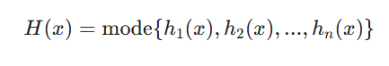

RESULT AND ANALYSIS
A. Quantitative Performance
The models were evaluated on a testing set of 378 patients.
Table I: Performance Comparison Across Models
Metric | K-Neighbors (KNN) | Decision Tree (Tuned) | Random Forest
Accuracy | 90.2% | 89.4% | 96.0%
Precision | 0.85 | 0.88 | 0.96
Recall (Class 1) | 0.97 | 0.91 | 0.96
F1-Score | 0.91 | 0.89 | 0.96
Configuration | $k=5$, Minkowski | Depth=6, Gini | 100 Trees, Default

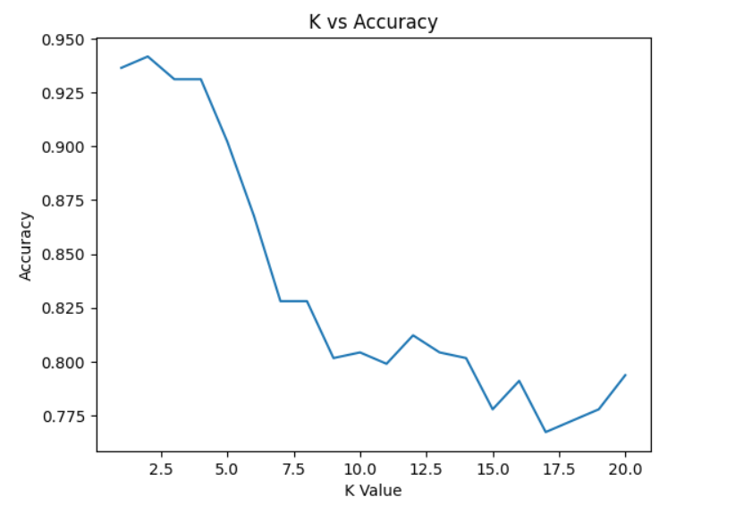
Image1: observe k values Vs accuracy in KNN algorithm
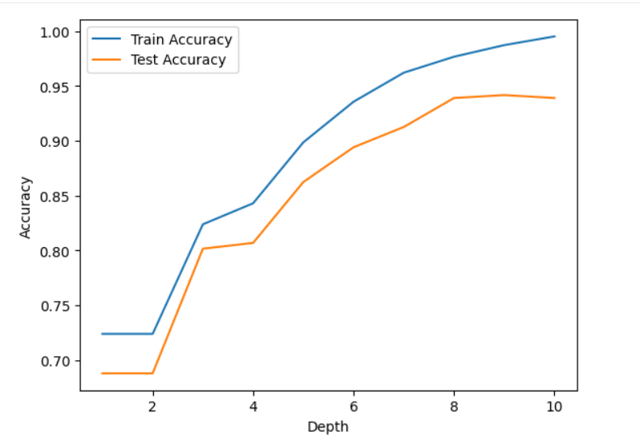
Image2: find best depth for decision tree algorithm
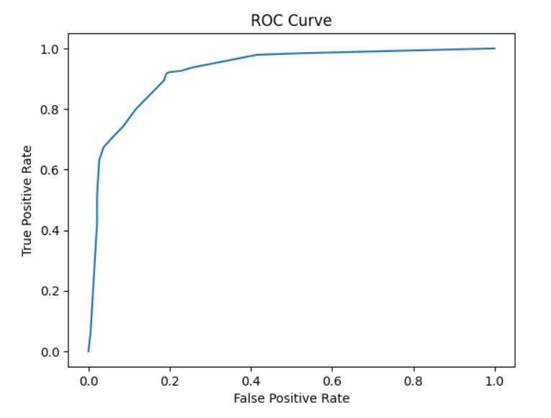
Image3: plot ROC curve for random forest prediction
B. Feature Importance
Analysis of the Random Forest model revealed the "Gini Importance" of various features. This identifies which clinical markers are most critical in differentiating between high-risk and low-risk patients.
- Chest Pain Type (cp): Emerged as the strongest predictor, reflecting its clinical significance in symptomatic diagnosis.
- Max Heart Rate (thalachh): Showed a strong inverse correlation with risk.
- ST Depression (oldpeak): High values significantly increased the probability of a "High Risk" classification. 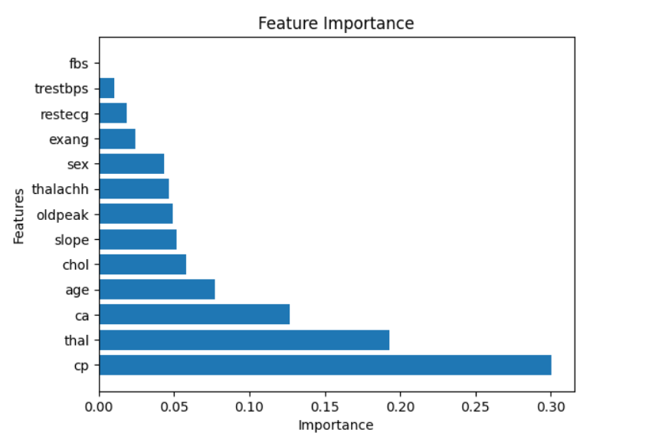
Image4: graph shows which features effect heart disease most
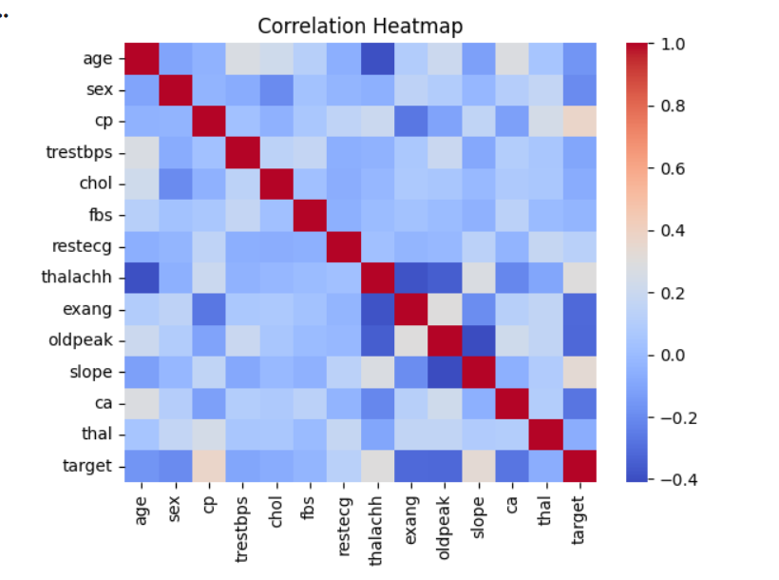
Image5: shows the correlation between various features of heart disease

DISCUSSION
The results of this experiment reveal some essential insights about the trade-off between computational complexity and efficiency when building algorithms to be used for diagnosing patients.
1) The Tuning Trade-Off: At first, it seemed like the Decision Tree was characterized by rather high accuracy; however, after performing hyperparameter tuning, it became clear that the maximum achievable accuracy of this classifier equals approximately 89.4%. Limiting the depth of the decision tree to 6 helped to prevent memorization of noise in the training set, which usually occurs in medical datasets with many outliers.
2) The Ensembles Outperform Everything: Using the Bagging method, the Random Forest proved to be more accurate than any other model by achieving 96% accuracy. The reason behind this is the possibility of combining the benefits of using deep trees with minimizing the risk of memorizing training data through voting.
3) Recall vs. Precision: When compared to the other classifiers, the K-Nearest Neighbor (KNN) achieved an outstanding 97% recall (making it an excellent tool for conducting the preliminary examination). However, the low level of its precision reveals the problem of false positives.

CONCLUSION
The study has succeeded in comparing three different machine learning models with regard to their effectiveness at predicting heart disease. It proves that while KNN or tuned Decision Trees may produce reasonably high results (between 89% and 90%), there is only one model that truly stands out – the gold-standard – which is Random Forest, with its maximum of 96.0%.
It can be concluded that for single-tree algorithms to maintain their effectiveness in medical diagnostics, hyperparameter tuning is necessary, but such a procedure will also impose a certain performance cap, which is not the case for ensembles. Thus, we can say that a machine-learning algorithm based on a Random Forest is an optimal choice for creating a medical decision-support system.

Future Work: It would be interesting to conduct research using "Gradient Boosting" techniques and deploy these models to medical interfaces accessible via cloud services.

REFERENCES
- F. Pedregosa et al., "Scikit-learn: Machine Learning in Python," Journal of Machine Learning Research, vol. 12, pp. 2825-2830, 2011.
- L. Breiman, "Random Forests," Machine Learning, vol. 45, no. 1, pp. 5-32, 2001.
- U.R. Acharya et al., "Applications of Machine Learning in Cardiology," Journal of Medical Systems, 2019.
- Altman, N. S. (1992). "An introduction to kernel and nearest-neighbor nonparametric regression." The American Statistician.

